**Baseline Data Summary of**

**Frequency, Intensity, Duration, and/or Latency**

Student’s Name: Click here to enter text. Date of Birth: Click here to enter a date.

Problem Behavior of Concern: Click here to enter text.

Staff Member Completing Form: Click here to enter text.

Baseline Data From: Click here to enter a date. Until Click here to enter a date.

Directions: Summarize 10 days of baseline data collection with the methods that were the most appropriate and relevant to measure the problem behavior of concern: Frequency, duration, intensity, and/or latency. Note: More days of data may be added.

|  |  |  |  |  |
| --- | --- | --- | --- | --- |
| **Baseline Days** | **Frequency** [Frequency = COUNT of NUMBER of TIMES the behavior occurred] (Example: 3 times on Day 1) | **Duration** [Duration = LENGTH of TIME each behavior lasted] | **Intensity** [Intensity = SEVERITY (1-5) of each occurrence] (5 levels defined below)  (Example: Level 1, Level 2, Level 2 on day 1) | **Latency** [Latency = LENGTH of TIME DELAY from antecedent to start of each behavior]  (Example: 8 min, 7, min, 9 min on Day 1) |
| Day 1 |  |  |  |  |
| Day 2 |  |  |  |  |
| Day 3 |  |  |  |  |
| Day 4 |  |  |  |  |
| Day 5 |  |  |  |  |
| Day 6 |  |  |  |  |
| Day 7 |  |  |  |  |
| Day 8 |  |  |  |  |
| Day 9 |  |  |  |  |
| Day 10 |  |  |  |  |
| Totals | Times/10 days |  |  |  |
|  | ÷ number of days (10) | ÷ frequency count | ÷ frequency count | ÷ frequency count |
| Baseline Averages | Times per day | Average duration of each occurrence | Average Intensity of each occurrence | Average latency of each occurrence |
| Range: Low to High | Range: _____ to_____ | Range: _____ to_____ | Range: _____ to_____ | Range: _____ to_____ |

|  |  |
| --- | --- |
| Define Intensity Levels of Problem Behavior: | Example of Intensity Levels for Problem Behaviors |
|  | 1. Only Impacts the student |
|  | 1. Impacts others in immediate area |
|  | 1. Impacts everyone in class |
|  | 1. Impacts other classrooms or common areas |
|  | 1. Impacts entire school or seriously dangerous or violent behavior |

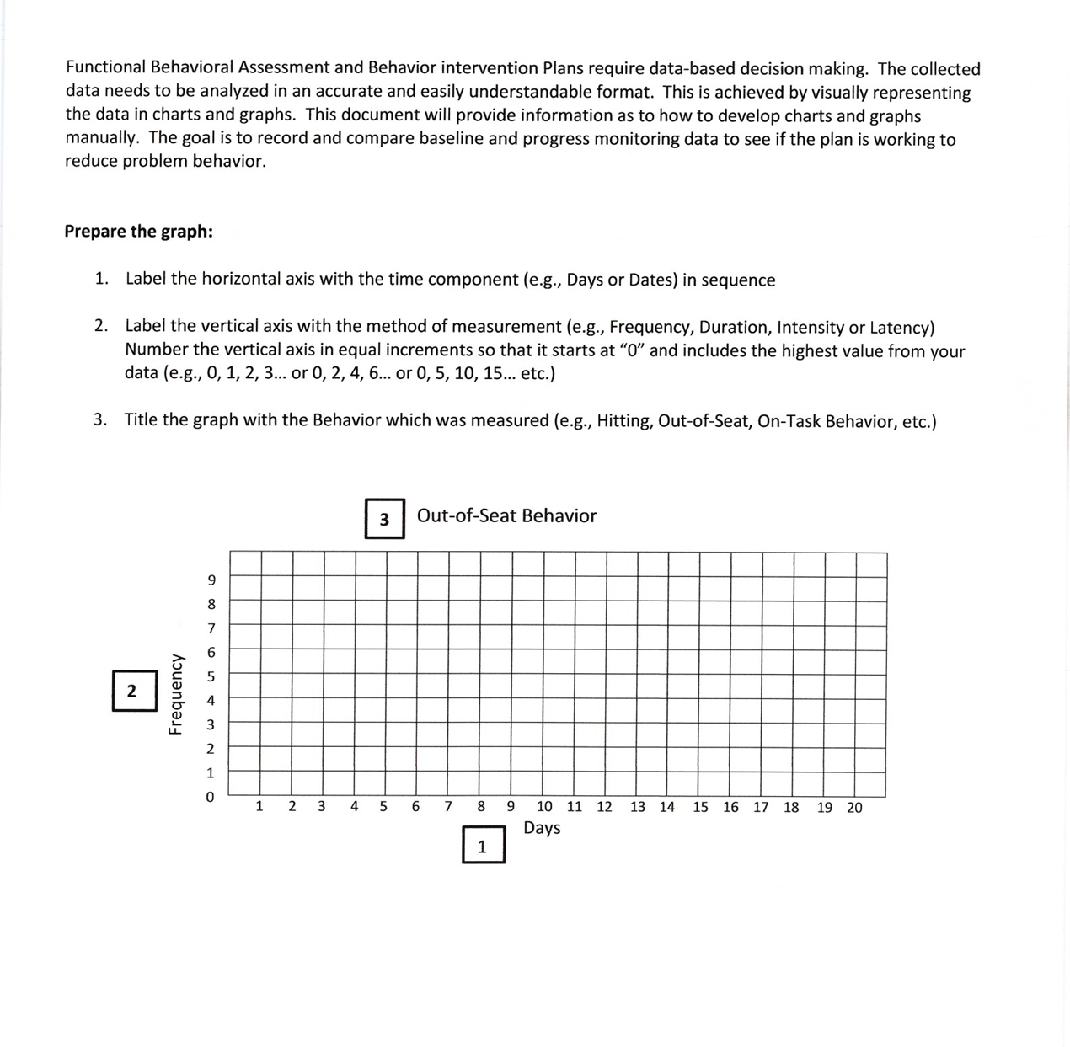

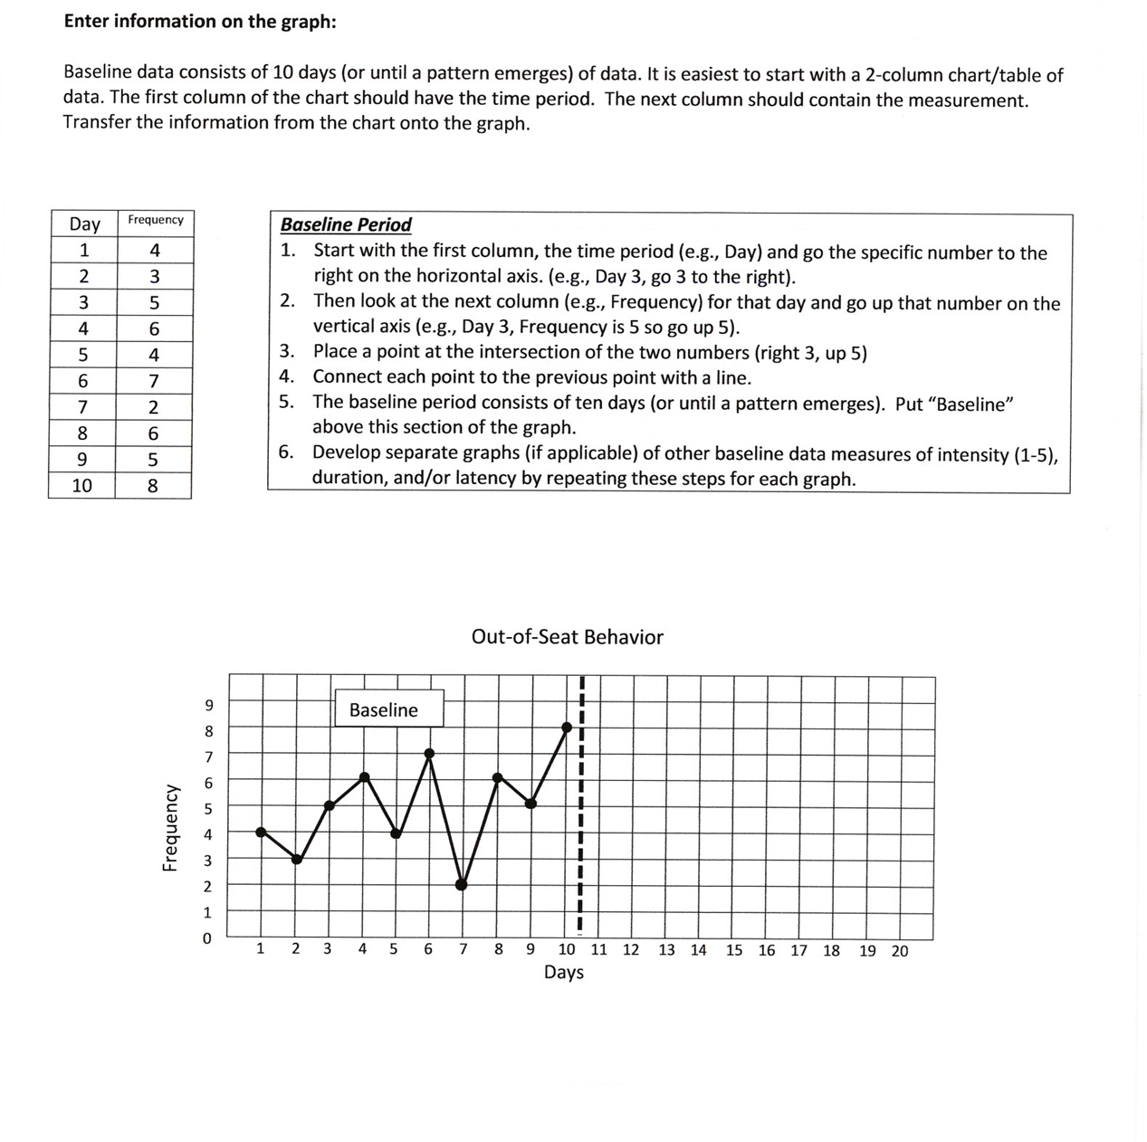

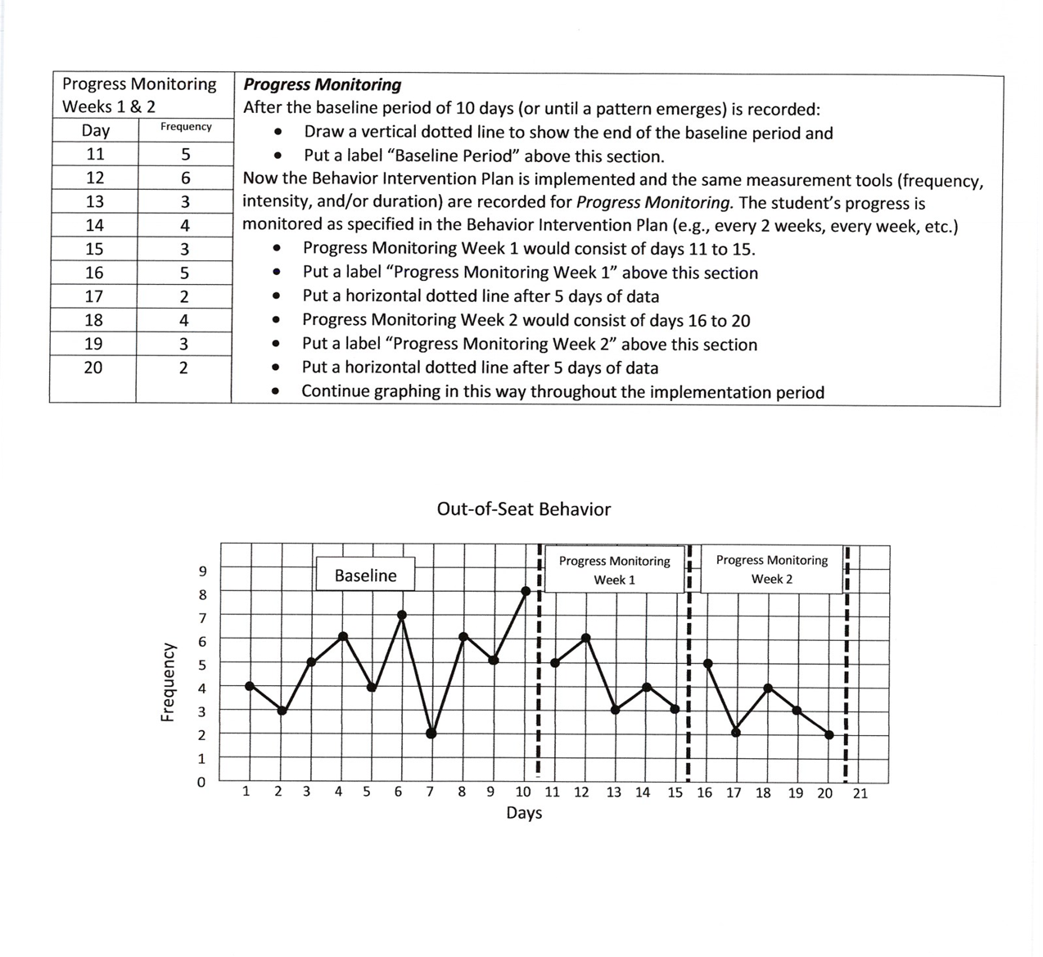

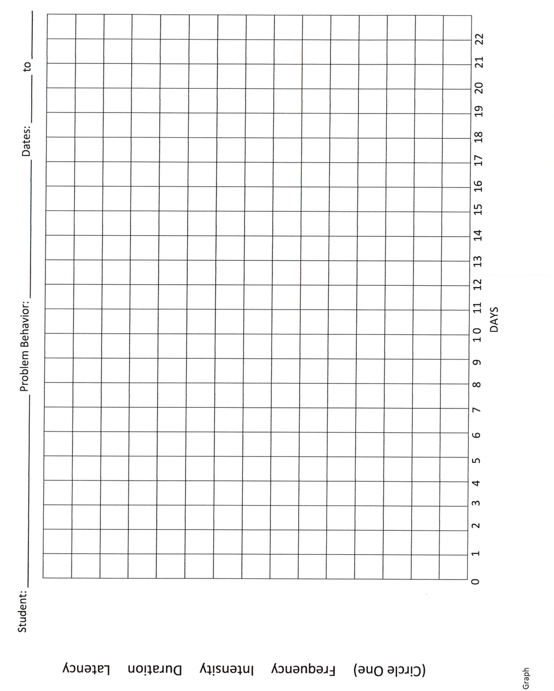

BASELINE DATA & PROGRESS MONITORING TOOL for

BEHAVIOR INTERVENTION PLANS

THREE GRAPHS-FREQUENCY, INTENSITY, DURATION/LATENCY

**PROGRESS MONITORING DATA WEEK #s** Click here to enter text.

Student’s Name: Click here to enter text. Date of Birth: Click here to enter a date.

Problem Behavior of Concern: Click here to enter text.

Staff Member Completing Form: Click here to enter text.

Baseline Data From: Click here to enter a date. Until Click here to enter a date.

Graph the data from Baseline (10 days) and Progress Monitoring Intervals, as specified in the Behavior Intervention Plan. List the dates on the horizontal axis at the bottom of the page and the range of numbers for each measure on the vertical axis to fi t the data {0, 1, 2...10; or 0, 2, 4 ...20; or 0, 5, 10...100).

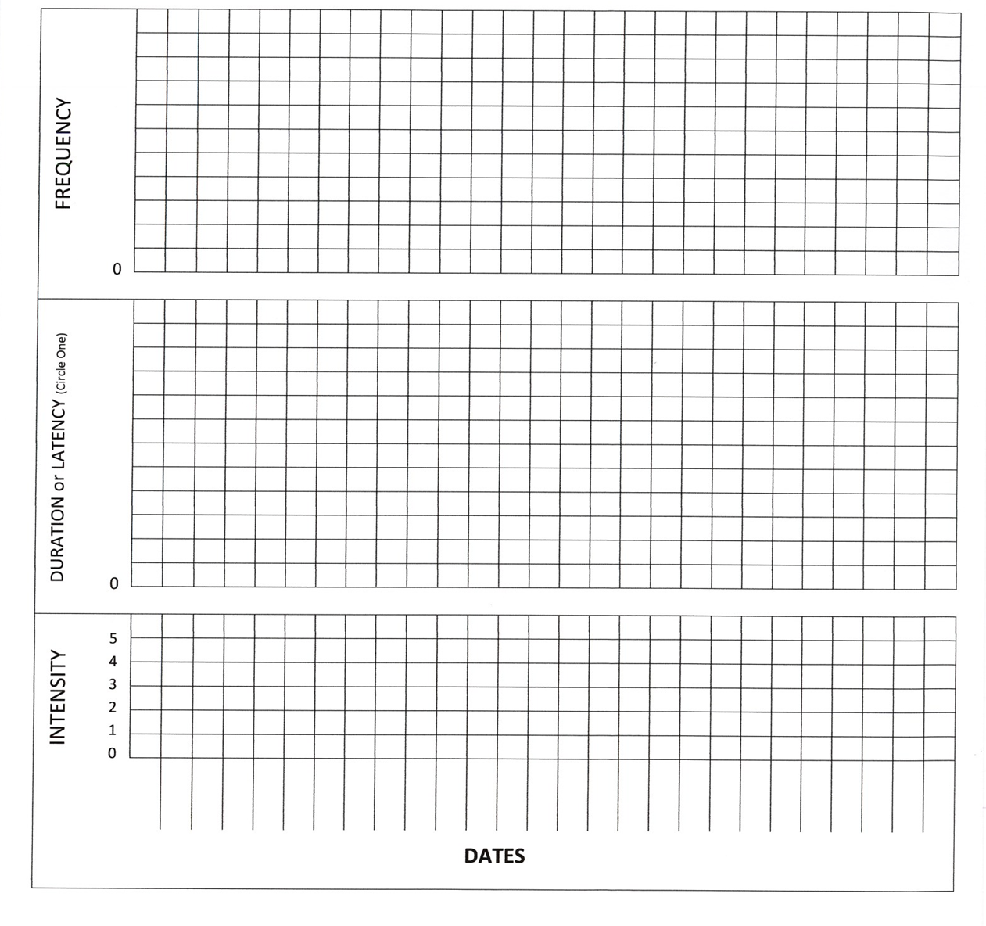

**Duration Recording Form**

Student’s Name: Click here to enter text. Date of Birth: Click here to enter a date.

Problem Behavior of Concern: Click here to enter text.

Staff Member Completing Form: Click here to enter text.

Baseline Data From: Click here to enter a date. Until Click here to enter a date.

|  |  |  |  |  |
| --- | --- | --- | --- | --- |
| Date | Class/Activity | Time behavior began | Time behavior stopped | Total time the behavior lasted |
|  |  |  |  |  |
|  |  |  |  |  |
|  |  |  |  |  |
|  |  |  |  |  |
|  |  |  |  |  |
|  |  |  |  |  |
|  |  |  |  |  |
|  |  |  |  |  |
|  |  |  |  |  |
|  |  |  |  |  |
|  |  |  |  |  |
|  |  |  |  |  |
| Grand Total | | | |  |

Duration Range: Shortest duration: Longest duration:

Range:

to

|  |  |  |
| --- | --- | --- |
| Duration Mean: | Add the durations of all observed behaviors and divide by the total number of the observations | Average Duration: |

### Latency Recording Form

Student’s Name: Click here to enter text. Date of Birth: Click here to enter a date.

Problem Behavior of Concern: Click here to enter text.

Staff Member Completing Form: Click here to enter text.

Baseline Data From: Click here to enter a date. Until Click here to enter a date.

|  |  |  |  |  |
| --- | --- | --- | --- | --- |
| Date | Class/Activity | Enter time that request or opportunity was presented to the student | Enter time student started the behavior | Amount of time for behavior to start |
|  |  |  |  |  |
|  |  |  |  |  |
|  |  |  |  |  |
|  |  |  |  |  |
|  |  |  |  |  |
|  |  |  |  |  |
|  |  |  |  |  |
|  |  |  |  |  |
|  |  |  |  |  |
|  |  |  |  |  |
|  |  |  |  |  |
| Grand Total | | | |  |

Latency Range: Shortest Latency:

Longest Latency:

Range:

to

|  |  |  |
| --- | --- | --- |
| Latency Mean : | Add the latencies of all observed behaviors and divide by the total number of observations | Average latency: |